**Azure fundamental assignment 2**

1. What is serverless computing?

Serverless computing allows developers to build applications faster because they don't have to manage their infrastructure. For serverless applications, cloud service providers automatically provision, scale, and manage the infrastructure needed to execute code.

To understand the definition of serverless computing, it is important to note that the server continues to execute code. The name "serverless" comes from the fact that the tasks related to provisioning and managing infrastructure are invisible to developers. This approach allows developers to focus more on business logic and bring more value to the core of their business. Serverless computing helps teams be more productive, brings products to market faster, and enables enterprises to better optimize resources and focus on innovation.

1. Explain Azure subscriptions, management groups and resources.

**Azure subscriptions** help you organize access to Azure resources and determine resource usage reporting, billing, and payment methods. You can set up different billing and payment settings for each subscription, so you can set up different subscriptions and plans for different offices, departments, projects, and so on.

**Azure management groups** help you manage by grouping your Azure subscriptions. If your organization has a large number of subscriptions, you may need a way to efficiently manage access, policies, and compliance for those subscriptions. The Azure management group provides a pane above the subscription.

**The resource group** is a container that contains resources related to your Azure solution. Resource groups contain resources that you manage as a group. Determine which resources belong to a resource group based on what is most meaningful to your organization.

1. Explain Azure regions, availability zones, and region pairs.

**Azure Regions**

Azure regions are a group of data centres connected by a dedicated low-latency network. The number of data centres contained in the region. Well, there is no fixed number. it's different. There are areas of various sizes. Regions can consist of a single data centre or multiple data centres. It's important to note that an Azure region is a group of one or more Azure data centres. At the time of this record, Azure has 58 regions around the world. You have the flexibility to deploy your applications and data to any Azure region. It can also be expanded to multiple regions to provide restoring force between regions.

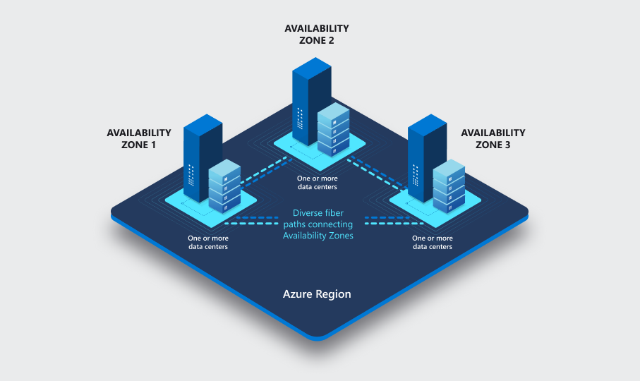

**Availability Zones**

The Azure Availability Zone is a unique physical location within an Azure region. Each Availability Zone consists of one or more data centres with independent power, cooling, and networks. Not all regions have Availability Zones. Regions that support Availability Zones have at least three separate zones to ensure restoration.

If one of the Availability Zones goes down for some reason, the application and data will be available in the other two Availability Zones. There is a physical separation between each Availability Zone, which protects applications and data from data centre failures. With an Availability Zone, Azure offers the industry's highest SLAs with 99.99% VM availability.

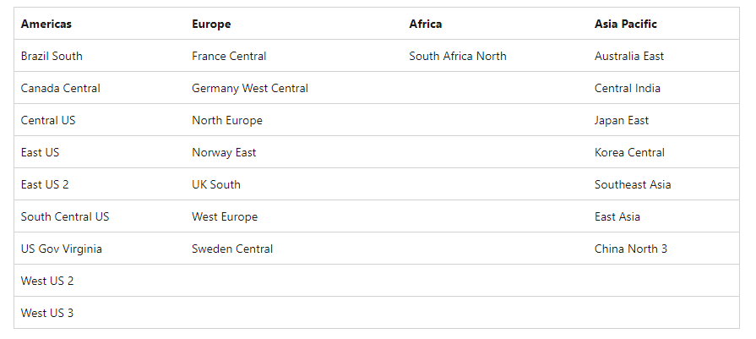

**Region Pairs**

Azure region pair, pair region, or region pair. All of these terms are used interchangeably and refer to the same thing. A regional pair is two regions within the same region. As you can see in the photo, Azure Geography is at the top level. As mentioned earlier, Azure geography is a region of the world that contains one or more Azure regions.

For example, India, the United States, Europe, and the Asia Pacific are examples of Azure regions.

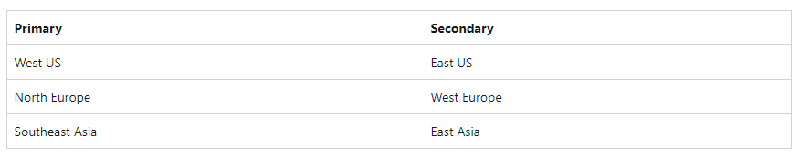

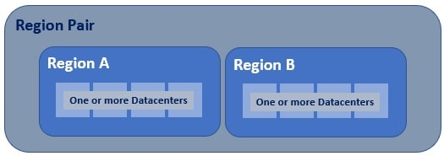

The Azure region consists of one or more data centres. If Availability Zones are enabled, the Azure region contains at least three Availability Zones. Availability zones consist of one or more data centres. This means that your Azure region contains one or more data centres, or three or more Availability Zones if enabled. Most regions within the region are paired to ensure business continuity and disaster recovery (BCDR).

The following is an example of a paired Azure region. See Microsoft's official documentation for a complete list of paired Azure regions. A pair of regions consists of two regions within the same region. However, there are exceptions to this. The southern part of Brazil is paired with the central and southern part of the United States, which is clearly outside the geographic area of ​​Brazil.

1. Explain Azure Resource Manager, Azure subscription and management group.

**Azure Resource Manager**

Azure management groups help you manage your Azure subscriptions by grouping them together. If your organization has many subscriptions, you might need a way to efficiently manage access, policies, and compliance for those subscriptions. Azure management groups provide a level of scope above subscriptions.

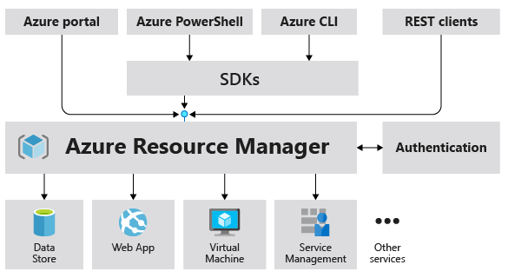

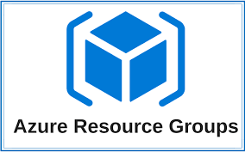 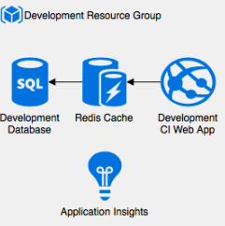 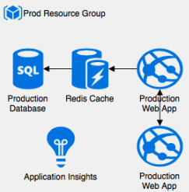

**Azure subscription**

**Azure subscriptions** help you organize access to Azure resources and determine how resource usage is reported, billed, and paid for. Each subscription can have a different billing and payment setup, so you can have different subscriptions and plans by office, department, project, and so on.

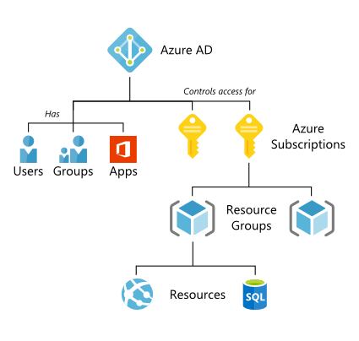

**Management group**

If your organization has many Azure subscriptions, you may need a way to efficiently manage access, policies, and compliance for those subscriptions. Management groups provide a governance scope above subscriptions. You organize subscriptions into management groups the governance conditions you apply cascade by inheritance to all associated subscriptions.

Management groups give you enterprise-grade management at a scale no matter what type of subscriptions you might have. However, all subscriptions within a single management group must trust the same Azure Active Directory (Azure AD) tenant.

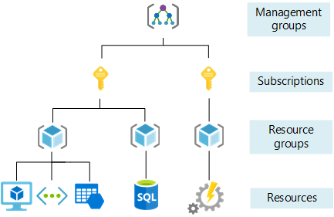

1. Provide an overview of Azure Compute Services.

Azure offers a variety of ways to host your application code. The term computing refers to a hosting model of the computing resources on which an application runs. The flowchart below will help you select the computing service for your application.

If your application consists of multiple workloads, evaluate each workload individually. A complete solution can include more than one computing service.

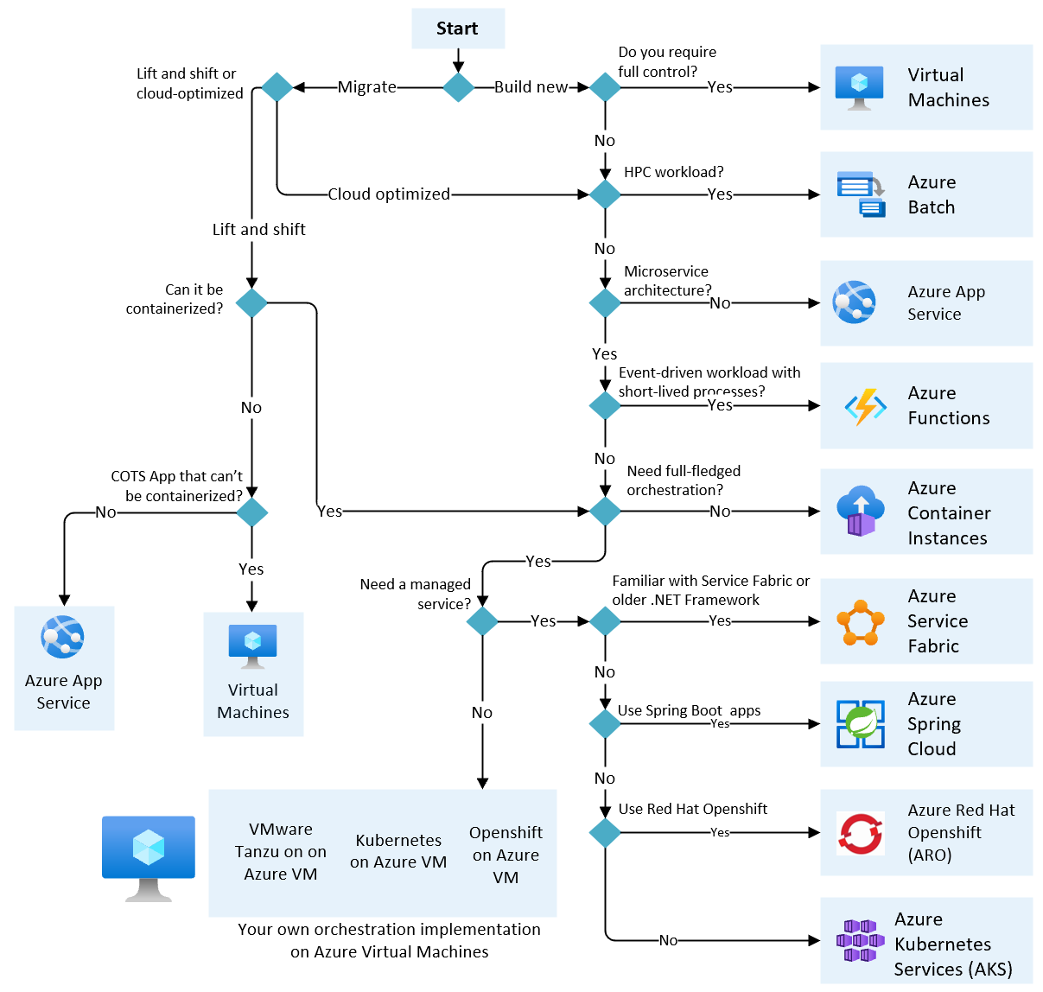

"Lift and shift" is a strategy for migrating workloads to the cloud without having to redesign your application or change your code. Also known as rehosting. For more information, see Azure Migration and Modernization Center.

Cloud-optimized is a strategy for moving to the cloud by refactoring applications to take advantage of cloud-native capabilities.

1. What is an Azure virtual machine and when to opt for an Azure virtual machine?

Azure Virtual machine will let us create and use virtual machines in the cloud as Infrastructure as a Service. We can use an image provided by Azure, or partner, or we can use our own to create the virtual machine.

Virtual machines can be created and managed using:

* Azure Portal
* Azure PowerShell and ARM templates
* Azure CLI
* Client SDK's
* REST APIs

The common types of Azure virtual machines are

* **General Purpose:** It has a balanced CPU to memory ratio which is suitable for testing and deployment of databases ranging from small to medium.
* **Compute-optimized:** This type of Azure VMs has a high CPU to memory ratio. It is the best option for medium traffic web servers, network equipment, and application servers.
* **Memory Optimized:** The memory-optimized Azure VMs have high memory to CPU ratio. It is good for relational database servers, medium to large caches and for memory analytics.
* **Storage Optimized:** This type of VMs possesses high disk throughput and IO ideal for data warehousing, NoSQL databases, SQL, Big Data, and big transactional databases.
* **GPU:** GPU is a specialized type of Azure Virtual Machines that are targeted for heavy graphics rendering and video editing purposes. They can also be used for modern training and differencing with deep learning. The user can avail of either single or multiple GPUs.
* **High-Performance compute:** These types of Azure Virtual VMs are the fastest and most powerful CPU virtual machines that come with high-throughput network interfaces (RDMA).